

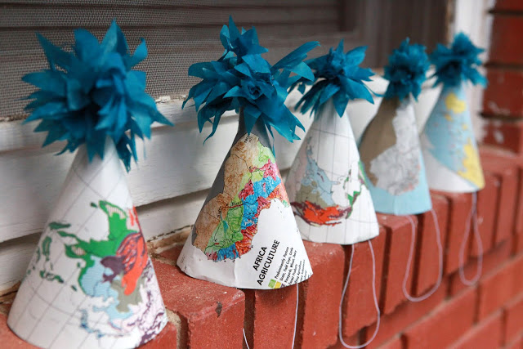

Entertainment Management
HTM2703

Theme: All Around the world
Taylor’s Education group dinner Proposal

Group Member:
Cham GhimWah 0303557  Chan Jiaweng 0304574  Chong Zhen Yu 0302190 | Hong Wee Lu 0304583  Katherine Chang 0303746  Kelly Lee 0303470

Prepared to: Ms. SharinaPuteh
Dateline: 24th June 2014
Themes
Our group chooses “all around the world” as our themes. We choose this as our themes because Taylor’s Education consists of Multicultural People. Our aim is to unite all different people from different cultural. In this way, we can learn and share about their cultural. Not only that, we also want to create a long lasting relationship among the staff

Location
We decided to choose Kuala Lumpur Convention Center (KLCC) for our event because KLCC’s banquet has lots of experience in setting up event. Furthermore, KLCC is big and enough to cater all of our staff together and stalls from world continents. (Africa, America, Asian, Australia, & Europe)

Purpose
Our purpose is to let the staff getting know more about each other’s and giving them a memorable and unforgettabledinner event.

Messages
Our message to all the staff is to; unite different culture in One Night.

Branding
One World, One nation, one Malaysia

Image
Image to the staff is “Life together covenant”. We desire to be the best that we can be in the realization of our personal and organizational aspirations. We will continually look for ways to be better than we were before, adopting continual learning as the path towards excellence in every aspect of what we do.
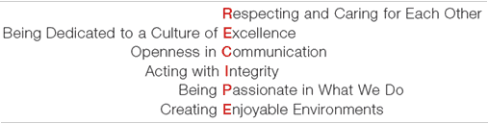

Catering
Our Set up will be in buffet style, a simple set up in 5 different stall. World continents include of Africa, America, Asian, Australia, & Europe. Each dish will be refilled, total of 450 pax per dishes

Asian Food
Thai Sticky Rice: Is a type of rice grown mainly in Southeast and East Asia, which has opaque grains, very low amylose content, and is especially sticky when cooked. It is called glutinousin the sense of being glue-like or sticky, and not in the sense of containing gluten. While often called "sticky rice", it differs from non-glutinous strains of japonica rice which also become sticky to some degree when cooked. There are numerous cultivars of glutinous rice, which include japonica, indica, and tropical japonica strains.

China Noodles: Chinese noodles are generally made from wheat flour, rice flour, or mung bean starch, with wheat noodles being more commonly produced and consumed in northern China and rice noodles being more typical of southern China.

Korean Tappoki: is a popular Korean snack food made from soft rice cake, fish cake and sweet red chili sauce.[2] It is commonly purchased from street vendors or pojangmacha. Originally it was called tteokjjim (떡찜) and was a savory braised dish of sliced rice cake, meat, eggs, and seasoning.

Japanese Sushi: is a Japanese food consisting of cooked vinegared ricecombined with other ingredients seafood, vegetables and sometimes tropical fruits. Ingredients and forms of sushi presentation vary widely, but the ingredient which all sushi have in common is riceor sumeshi. Sushi can be prepared with either brown or white rice. Sushi is often prepared with raw seafood, but some common varieties of sushi use cooked ingredients. Raw fish (or occasionally meat) sliced and served without rice is called sashimi.Sushi is often served with shredded ginger, wasabi, and soy sauce. Popular garnishes are often made using daikon.

Africa food
Potjiekos Traditional Stew: is a traditional Afrikaner dish hailing from South Africa.It is a simple dish, easy to prepare, with few 'rules' but hundreds of variants.

Moroccan Pastries: is a pastry filled with almond paste and topped with sugar. You can choose from plenty of Morrocan desserts like delicious almond sweetmeats, Lebanese date stuffed pastries which represents a popular Middle Eastern pastry; then you can try bourtaka muhallabieh which means orange custard with caramel.

Kitcha fit-fit: is a combination of shredded kitcha (Tigrinya) (or kita in Amharic), berbere, and clarified butter. Kitcha fit-fit is sometimes eaten with plain yogurt (urgo in Amharic and rug-o in Tigrinya).

Couscous:is a traditional Berber dish of semolina (granules of durum wheat) which is cooked by steaming. It is traditionally served with a meat or vegetable stew spooned over it.

Australia Food
Pavlova: Pavlova is a meringue-based dessert named after the Russian ballet dancer Anna Pavlova.It is a meringue dessert with a crisp crust and soft, light inside.

Prawn cocktail:is a seafood dish consisting of "shelled prawns in Marie Rose sauce, served in a glass.

Roast kangaroo:is from any of the species of kangaroo.

Pizza:is an oven-baked flat bread typically topped with a tomato sauce, cheese and various toppings. Pizza is cooked in various types of ovens, and a diverse variety of ingredients and toppings

Europe Food
Goose Liver: also know asFoie Gras. It is a popular and well-known delicacy in French cuisine. Its flavor is described as rich, buttery, and delicate, unlike that of an ordinary duck or goose liver.

Choices of Seafood:is any form of sea life regarded as food . Prominently includes fish and shellfish. Shellfish include various species of molluscs, crustaceans, and echinoderms.

Pasta (vegetarian) :Pasta is a staple food of traditional Italian cuisine. pasta is made from an unleavened dough of a durum wheat flour mixed with water and formed into sheets or various shapes, then cooked and served in any number of dishes.

Macaron: is a sweet meringue-based confection made with eggs, icing sugar, granulated sugar, almond powder or ground almond, and food colouring. The macaron is commonly filled with ganache, buttercream or jam filling sandwiched between two biscuits.

America Food
Mini Hamburger:is a sandwich consisting of one or more cooked patties of ground meat (usually beef) usually placed inside a sliced hamburger bun. Hamburgers are often served with lettuce, bacon, tomato, onion, pickles, cheese and condiments such as mustard, mayonnaise, ketchup and relish.

Mashed Potato:is a dish prepared by mashing boiled potatoes. To get taste and creamy texture, Mashed potato can bee add in with melted butter and cream. Also Herbs to enchance the taste.

Coleslaw:is a salad consisting primarily of finely-shredded, raw cabbage, and dressed most commonly with a vinaigrette (mayonaise) salad dressing.

Apple Pie:is a fruit pie (or tart) in which the principal filling ingredient is apple.
Beverage

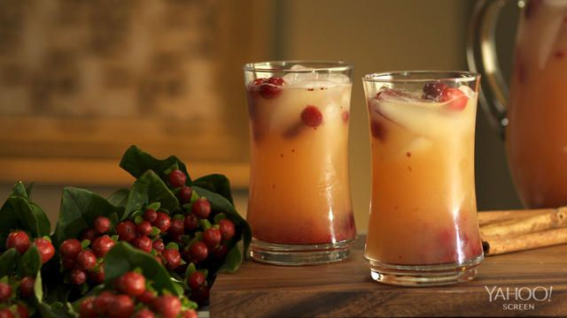
- Autumn Chiller
1 to 2 tablespoons cranberry sauce (depending on how sweet it is)
2 ounces orange juice, 3 ounces ginger beer
1/2 lemon juice
Stir with a cinnamon stick


- Agave Cranberry Punch
1 (750 ml) bottle Soda water
1 cup Cranberry Juice
1/2 cup Lemon syrup

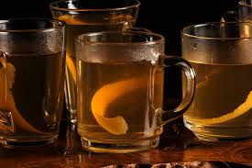
- Amber Cider Punch
1/2 cup sugar
1/2 tsp cinnamon
1/2 tsp all spices
1/2 tsp nutmeg
2 cups apple cider
6 unfrozen orange juice concentrate
2 cups ginger ale

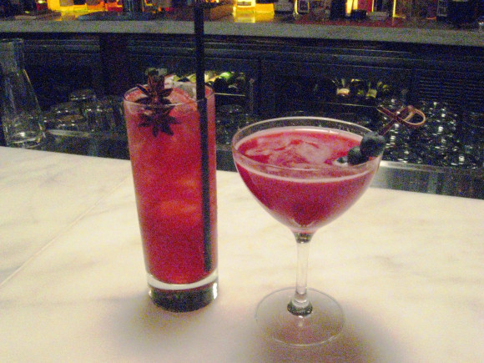
- Pomegranate Princess
2 oz. Citrus Burst HYDRIVE Energy Water
2 oz. Chamomile Tea (brewed Double Strength)
1 oz. Blueberry Simple Syrup
1 oz. Lemon Juice
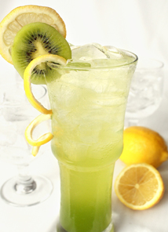
- Flossy Aussie
12 1/2 ml Lime Juice
12 1/2 ml Simple Syrup
50 ml Kiwi Juice
50 ml Bitter Lemon Soda
3 Kumquats halved
1/4 Kiwi diced with skin on
Skewer of Kiwi and Kumquats

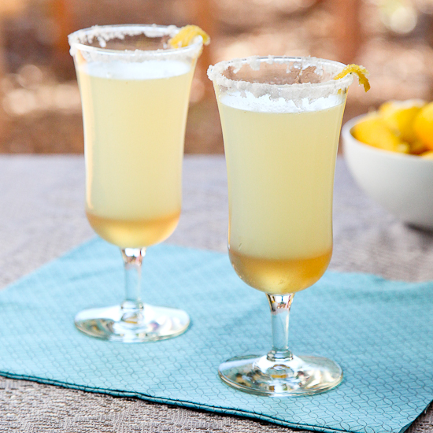
- Sparkling Mocktail
3 inches of fresh ginger root, sliced into coins
¾ cup sugar, plus extra for tossing the ginger
1½ cups water
½ cup freshly squeezed lemon juice (from 4-6 lemons)
Seltzer water to fill the glasses (about 3 cups)
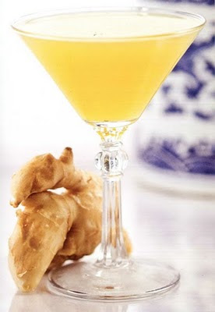
- Apricot Gingertini
2 1/2 oz white grape juice
3 oz apricot nectar
1 oz ginger-infused simple syrup
1/4 tsp ground clove

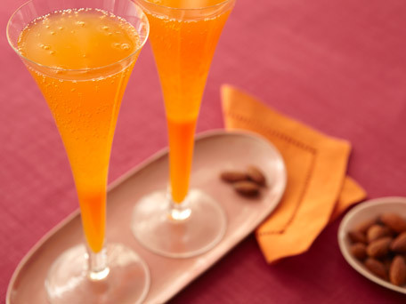
- Passion Punch
2 ounces peeled fresh ginger, thinly sliced (about 1/2 cup)
1/2 cup sugar
1/2 cup water
3/4 cup well-chilled passion fruit juice
2 tablespoons lemon juice (4 strips of zest removed with a sharp vegetable peeler before juicing and reserved for garnish)
2 teaspoon grenadine
1 (750 ml) bottle well-chilled Cava

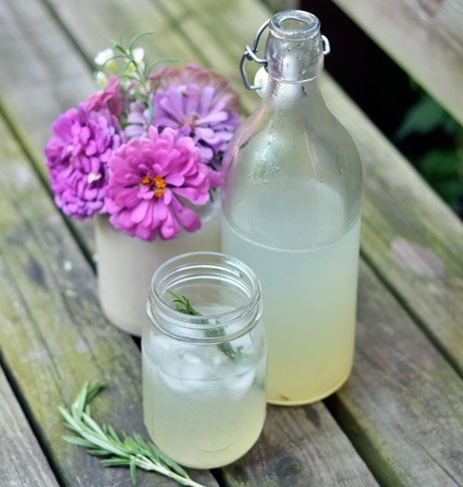
- Mock-Mosa
1 cup lime juice (from about 6 limes)
3/4 cup sugar
Peel of 2 limes
Two 4-inch sprigs fresh rosemary
4 to 6 cups chilled sparkling water

Environment
Decoration item
-Balloons with Printed country flag
-we use balloon to create atmosphere. Colorful balloons everywhere and different country flag hanged on each of the chair and stage to match our themes.
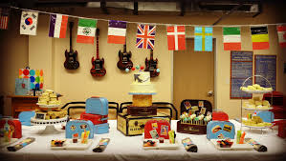
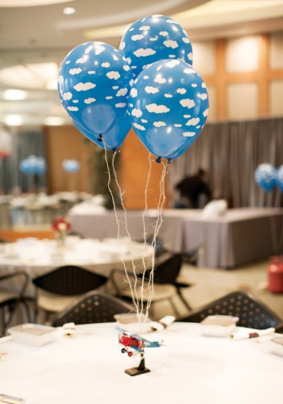

Props:
-China Panda (Asian)
-We choose to use Panda as panda is within the 5 continent, Panda known as world famous animal and it is one of the world’sattractions that almost extinct.
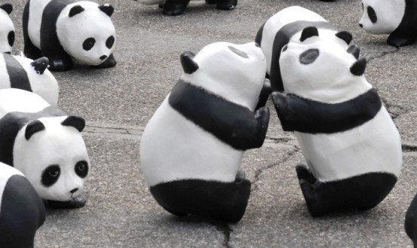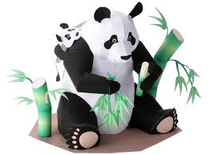

-Kangaroo (Australia)
-We choose to use Kangaroo as this animal is Australia’s trademarks, which also listed as endangered animals. Kangaroos have powerful hind legs and short, thumb lessforelimb. These habitats are grazing herbivores.
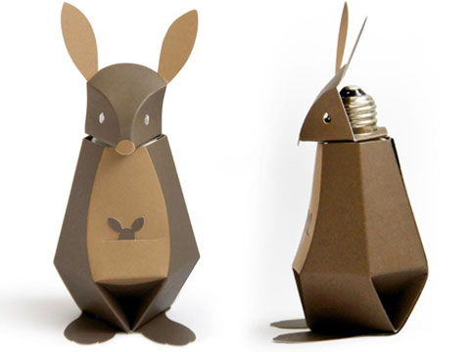

-Eiffel Tower (Europe)
-Eiffel tower is a famous tourist attraction where it located on the champ de Mars in Paris. And it names after the engineer Gustave Eiffel. Every one dreams on going to Paris. We created an Eiffel tower out of cardboard to create atmosphere.
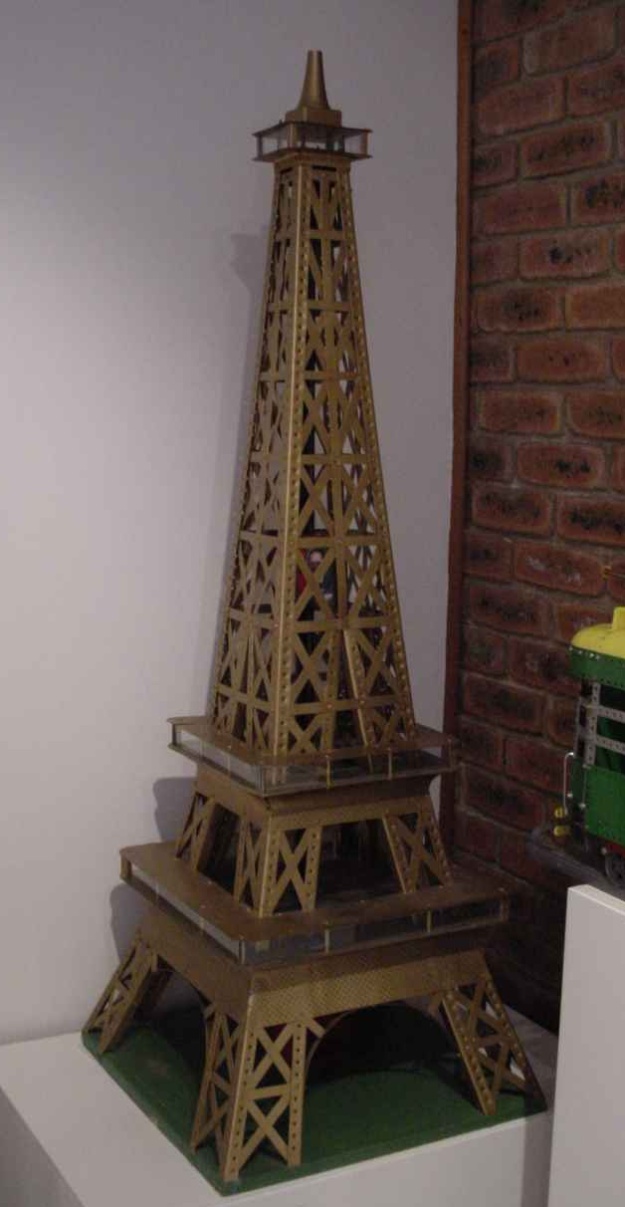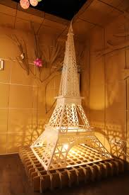

-Lion King (Africa)
-I believe everybody watches “Disney Lion King”. We choose lion king as we know that lion is the king of the jungle. Lion represent Africa, which is one of the 5 continent.
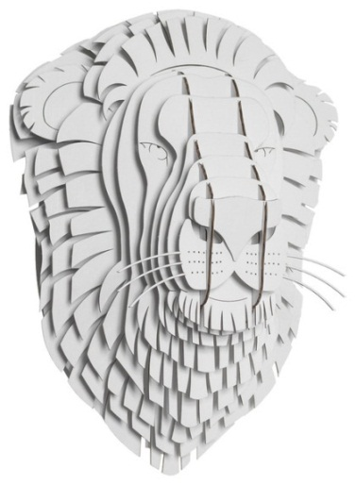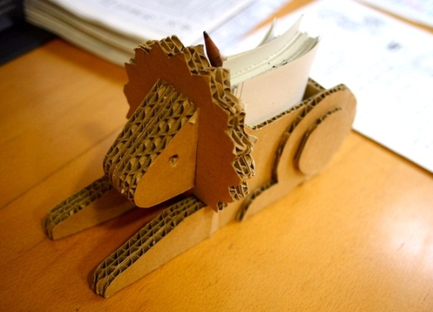

-Statue of Liberty (America)
-Statue of liberty, sits on 12-acre Liberty Island in New York Harbor. This statue represented freedom from tyranny, financial hardship and suffering for many immigrants since 1800. This statue is given by French to US as a gift to mark the centennial of the American Declaration of Independence.
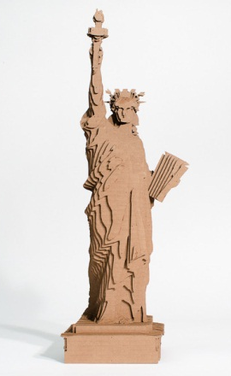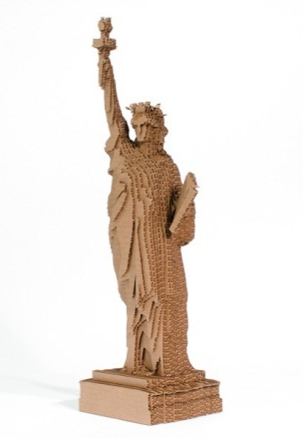

Furnishing
Round Table: We choose round table because we want to let the staff to get to know each other. The space in KLCCC is limited to type of set up. We will set up 150 round tables for 1500 people and extra 2 round table in case of extra guests coming.

Banquet round table chair: We choose this type of chair because we want to fit 10 chairs per table, and match our themes and set up. We will set 1500 chairs for 1500 peoples and extra 20 chairs for the extra 2 tables.

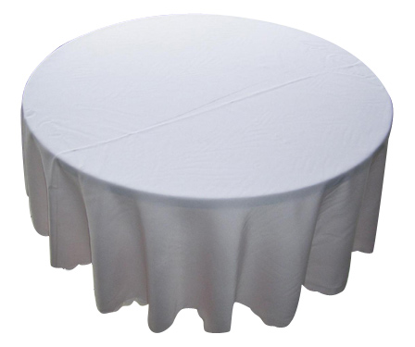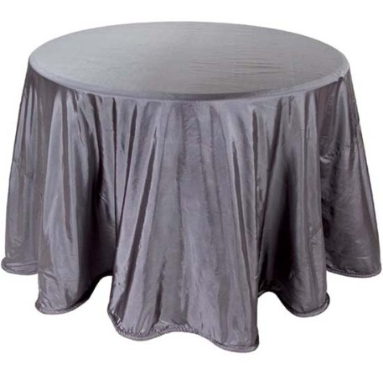

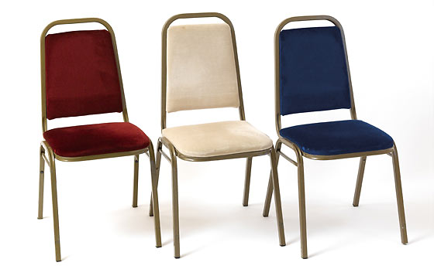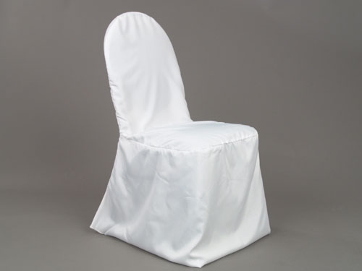

Entertaiment
Best Dress award. : Is for staff and lecturer best outfit.
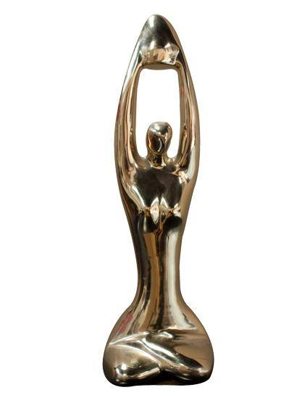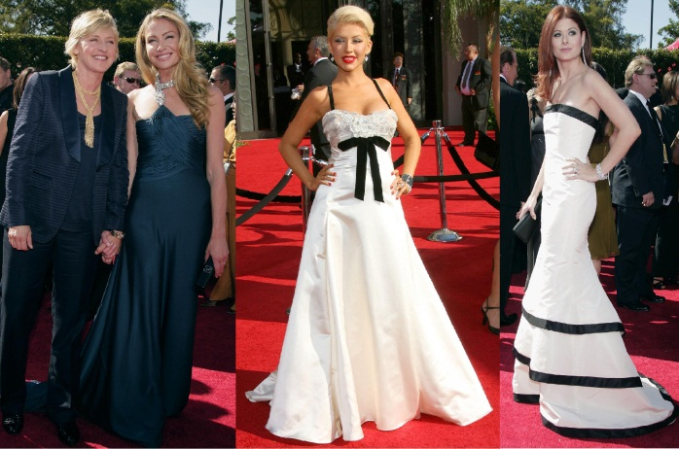

Best lecturers awards: (vote by students).
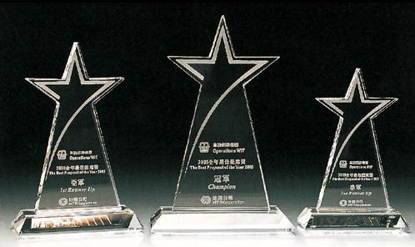

Lucky draw: lucky draw is divided into two sections. First lucky draw, the lucky number is stickled randomly under the water goblet. Meanwhile, second lucky 3 people will be chosen. Lucky numbers will be stick under their chair randomly.

Performance
First,
Singing by Jacky Cheung (Asia country)
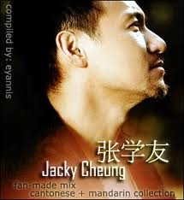
Contact Detail
company: china tianxin culture entertainment co.,LTD
contact number: +86 10 6510 1312 China Beijing

Second,
Fire performance (Africa)
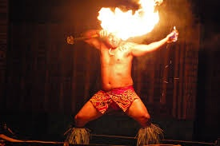
Contact detail
Company: JIGGEE (M) SDN. BHD.
42A, JalanLimauBesar, Bangsar Park, 59000 Kuala Lumpur, Malaysia.
Contact Number: +603 20954389
Email: get@jiggee.com

Third,
Singing by Beyonce (America)
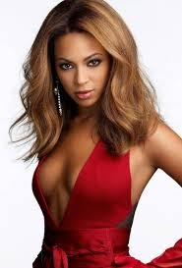
Contact Detail
Booking from BookingEntertainment.com
Contact Number: (212) 645-0555

Fourth
Pole dance performance
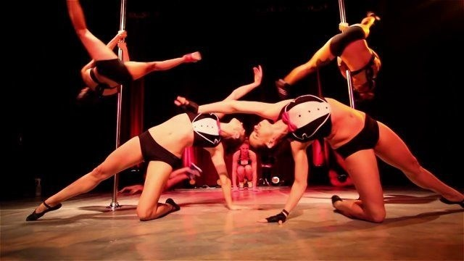
Contact detail
SP dance agency - 012-6161519
Email :entertainment@spmodels.net

Fifth
Magic performance (Europe)

Contact Detail
Company: We4Show S.n.c
Via G. Murat, 60 20159 Milano
Email: Info@we4Show.com

Worldwide booking: TAVEL INTERNATIONAL AGENCY
78, Avenue des Champs Elysees
75008 Paris, France.
Email: TAVELAG@aol.com

Games
“Titanic”- This is a game where we invite VIPs to stages to play. A basin filled with water and an empty bowl. Each of the VIPs will receive 10 marbles. They will start to drop a marble until the bowl sank. Whoever sank the bowl lose. Loser will receive a punishment which he or she needs to dance “chicken dance”.
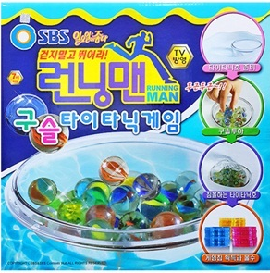

Menu puzzle - Before dinner begins, they play party games. Where the menus were puzzles, so each person got one piece of the puzzle at their place setting, then everyone had to put the pieces together to get the full menu description.


Typing Maniac – Is a game where event organizer will show a paragraph of words on projectors. Everyone in that event may participate. Whoever 1st number receives by the Event organizer with full complete words wins.
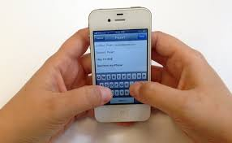

Lighting
- Mood of the light: exited happy fun
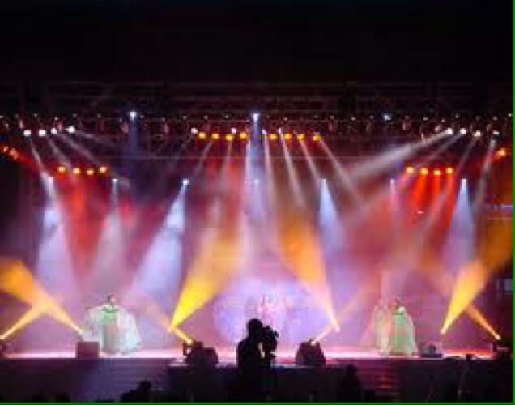
- Intensity brightness: based on performance by the performer.
- Color: bright color (light blue, pink, green, yellow etc.)
- Moving Head Beam Light: Pole dance -glow in the dark.
- Opening: Long Projection
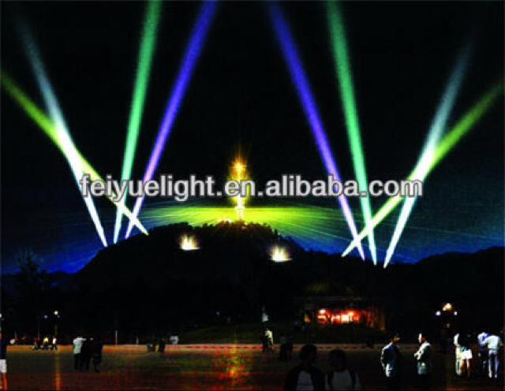

- Fire Performance: Long Projection
- Magician: PARcan

- Beyoncé: PARcan
- Jacky Cheung (singer): following spot light.
- Emcee: following spot light.
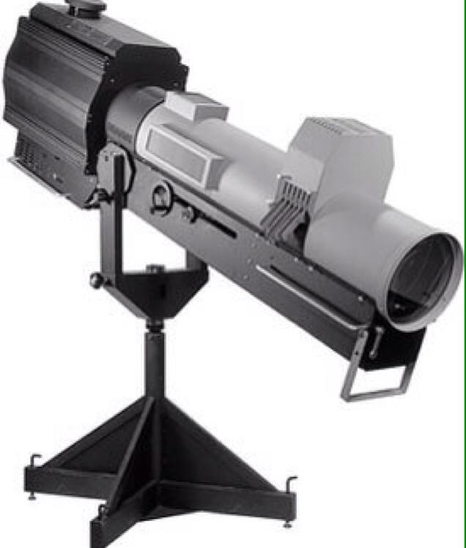
Prize
- Consolation Prize
.. Apple iPad Mini
.. Complimentary 4 buffet voucher in Shangri-la
.. Complimentary 2 days 1 night Ossoto for 2 pax
- Third Prize (3rd)
.. iMac
- Second prize (2nd)
.. Couple Watch from Montblanc
- First Prize (1st)
.. RM20000 + 2 Business Class air ticket

